The Reel of the 51st Confusion
32-bar reel for three couples in a three-couple longwise set

1 | – | 8 |  | 1st couple set, cast off two places and lead up, finishing back to back facing first corners.
9 | – | 16 |  | 1st couple set to first corners, then turn with right hand halfway. first corners give left hands in the middle and 1st couple and first corners balance in line. first corners turn with left hand one and a quarter times to end up back to back facing second corners.
17 | – | 24 |  | Repeat with first corners and second corners. At the last left-hand turn, finish on the lines with 1st, 2nd and 3rd women improper in 1st, 2nd and 3rd position respectively and 2nd, 3rd and 1st men improper in 1st, 2nd and 3rd position respectively.
25 | – | 32 |  | All dance six hands round and back.
 |  |  |  | Repeat from new positions.

Devised by Anne Lanvin, Corentin Lefèvre, Isabelle Herlant, Louise Baltera, Nicolas “Niols” Jeannerod and Victor Lanvin on August 8th, 2021. This dance is a variation on one of the most popular Scottish country dances, The Reel of the 51st Division.

Note: Remember the person that is at the left of your partner from your point of view: First, third and fifth times, you will start dancing with your partner on your original lines; Second, fourth and sixth times, you will start dancing with that other person on the opposite lines.

Recommended music: The Sober Piper, by Anne Lanvin. Alternatively, one can use one of the tunes for The Reel of the 51st Division: The Drunken Piper, by Alex McLeod.

The Sober Piper
32-bar reel by Anne Lanvin

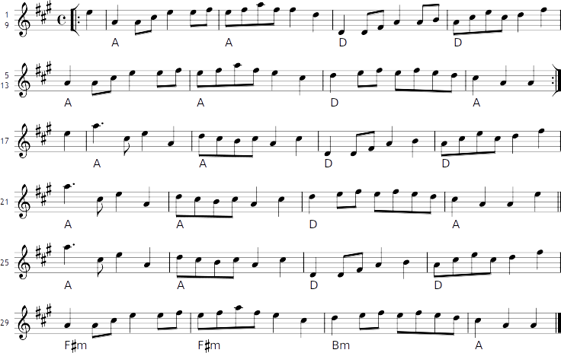

This tune is a variation on The Drunken Piper by Alex McLeod.

